Mechatronics System Integration (MCTA3203)
Week 8: Bluetooth Data Interfacing

Remote Monitoring System and Control via Bluetooth

Objective:
To create a wireless monitoring system using Bluetooth communication between an ESP32 and a computer/smartphone. The Arduino will read temperature data from a DHT22 sensor, send it over Bluetooth, and receive simple control commands from the paired device.

1. Required Hardware:
- ESP32 development board
- Temperature sensor (DHT22)
- Smartphone (Android or IOS)
- Power supply for the ESP32/Arduino
- Breadboard
- Jumper wires

2. Theory
The ESP32 facilitates Bluetooth communication by utilizing a 2.4 GHz radio frequency to transmit data packets through a process called Frequency-Hopping Spread Spectrum (FHSS), which prevents interference by constantly switching between 79 different channels. To connect via "Serial" to a phone, the ESP32 typically employs the Bluetooth Classic Serial Port Profile (SPP) or Bluetooth Low Energy (BLE) Nordic UART Service, creating a virtual wireless bridge that mimics a physical wired connection. Once paired, the phone treats the Bluetooth stream as a standard asynchronous serial interface (UART), allowing developers to use simple SerialBT.print() commands to send data strings that are encapsulated into Bluetooth packets, transmitted over the air, and then reassembled by a terminal app on the mobile device.

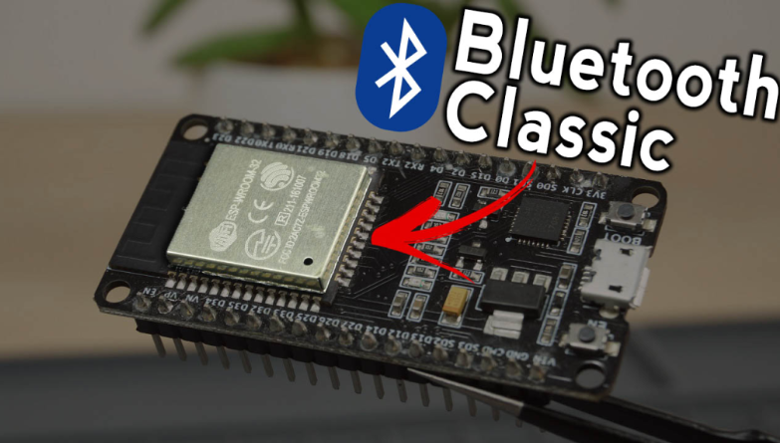
Figure 1 shows the ESP32 that has Bluetooth capabilities

3. Circuit Diagram
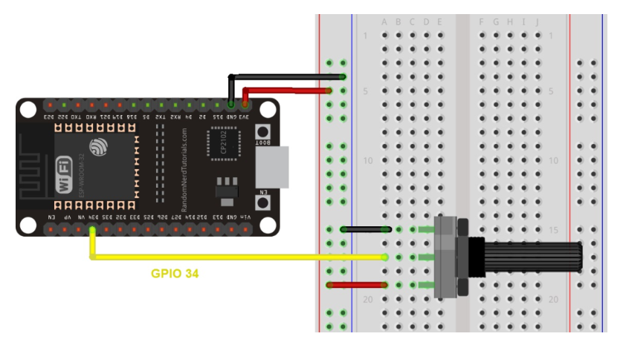
Figure 2 shows the picture of potentiometer connected to the ESP32

Experiment Steps:
- Connect the DHT22 Sensor as in the picture above
- Insert the following codes in Arduino IDE
- Download Serial Bluetooth Terminal by Kai Morich (Google Play Store) or Bluetooth Terminal by Bluetooth LE Smart Prototyping (Apple Store)
- Open the serial monitor on the Arduino IDE with the correct baud rate.
- Press the ESP32 Enable button
- Connect the smartphone with the ESP32
- Go to your following apps and add devices
- Observe the terminal for temperature reading

4. ESP32 Code Example
#include "BluetoothSerial.h"
BluetoothSerial SerialBT;
const int potpin = 34;
const int LED = 2; //Builtin LED
char command;
int potValue = 0;
void setup()
{
Serial.begin(9600);
SerialBT.begin("Group_Name");
Serial.println("Bluetooth initialized... Ready to receive commands.");
pinMode(LED,OUTPUT);
}

void loop()
{
if(SerialBT.available())
{
command = SerialBT.read();
Serial.print("Command received: ");
Serial.println(command);

switch (command)
{
case 'O':
digitalWrite(LED,HIGH);break;
case 'F':
digitalWrite(LED,LOW);break;
}

potValue = analogRead(potpin);
SerialBT.print("PotValue : "potValue);
Serial.print("PotValue : "potValue);
}
delay(2000);
}

Task 1

- Explain how Bluetooth can incorporate into IOT applications
- Change the setup so that it includes a servo and one sensor. Observe the serial terminal on the smartphone so that it can receive the value for the sensor and it can send certain command to control the servo.

References

- https://projecthub.arduino.cc/NeilChaudhary/arduino-bluetooth-basic-tutorial-9cff12
Arduino Bluetooth Basic Tutorial

- https://howtomechatronics.com/tutorials/arduino/arduino-and-hc-05-bluetooth-module-tutorial/
Arduino and HC-05 Bluetooth Module Complete Tutorial

- https://projecthub.arduino.cc/superturis/basic-bluetooth-communication-with-arduino-hc-05-3a431c
Basic Bluetooth communication with Arduino & HC-05

